Internal verification of assessment decisions – BTEC Higher Nationals (RQF)

INTERNAL VERIFICATION – ASSESSMENT DECISIONS (Single Student)
Programme Title: |  | Pearson BTEC HND in computing
Unit Number and Title: |  | 17 Business Process Support
Assessor Name: |  | N.F. Mafaza |  | Internal Verifier Name:
Assignment title: |  | Sales Data Analysis System for Sampath Food City (PVT) Ltd
Name of student | Submission Type  (First, Resubmission, Retake) | Grade the Assessor has awarded. | Assessment Decision Accurate (Y/N)  (Resubmission and retake must be capped at a Pass) | List the learning outcomes and grading criteria where inaccurate decisions have been made |  | State why the assessment decision is inaccurate.  *If an inaccurate decision is recorded the Internal Verifier must recommend actions detailing the issues to be addressed. The Assessor and the Internal Verifier must then confirm that the action has been undertaken before assessment decisions are issued to the student.
INTERNAL VERIFIER CHECKLIST |  |  |  |  |  |  | Y/N
Has the student and the Assessor confirmed the authenticity of the evidence?
Is there evidence of collusion or plagiarism? The work submitted for assessment has been carried out without assistance other than that which is acceptable according to the rules of the specification. The evidence submitted for this assignment is student’s own. The student has clearly referenced any sources and any artificial intelligence (AI) tools used in the work.
Is the assessor feedback to the student appropriate and constructive to each student? Provide comments below.
- Points out strengths and areas for improvement.
- Linked to relevant learning outcomes and assessment criteria.
- Clear as to why the student did not achieve higher grades.
- Identify opportunities for improved performance in future assignments.
GENERAL COMMENTS
Any actions required must be reviewed across the whole cohort.
Action Required |  |  |  |  | Target Date for Completion |  |  | Date Action Completed
I confirm that the assessment decisions are accurate, there is no evidence of assessment malpractice and any action points have been addressed and completed in respect of the whole cohort. I declare the work submitted for assessment has been carried out without assistance other than that which is acceptable according to the rules of the specification. The evidence submitted for this assignment is the student’s own. The student has clearly referenced any sources, and any artificial intelligence (AI) tools used in the work.
Internal Verifier signature |  |  |  |  | Date
Assessor signature |  |  |  |  | Date

Higher Nationals - Summative Assignment Feedback Form

Student Name/ID | MN. Sihanas/1030371
Unit Title | Business Process Support
Assignment Number | Assignment 01 | Assessor | N.F.Mafaza
Submission Date |  | Date Received 1st submission
Re-submission Date |  | Date Received 2nd submission
Assessor Feedback:

*Please note that constructive and useful feedback should allow students to understand:

- Strengths of performance
- Limitations of performance
- Any improvements needed in future assessments

Feedback should be against the learning outcomes and assessment criteria to help students understand how these inform the process of judging the overall grade.

Feedback should give full guidance to the students on how they have met the learning outcomes and assessment criteria.
I certify that to the best of my knowledge the evidence submitted for this assignment is the student’s own. The student has clearly referenced any sources and any artificial intelligence (AI) tools used in the work. I have not solely used AI to grade the student’s work.

Grade: | Assessor Signature: |  | Date:
Resubmission Feedback:
*Please note resubmission feedback is focussed only on the resubmitted work
Grade: | Assessor Signature: |  | Date:
Internal Verifier’s Comments:
Signature & Date:

* Please note that grade decisions are provisional. They are only confirmed once internal and external moderation has taken place and grades decisions have been agreed at the assessment board.
Pearson Education 2016
Higher Education Qualifications
Internal Verification of Assignment Brief

Student Assessment Submission and Declaration
When submitting evidence for assessment, each student must sign a declaration confirming that the work is their own.
Student name: MN. Sihanas |  | Assessor name: N.F.Mafaza
Issue date:  19/01/2025 | Submission date:  13/04/2024 |  | Submitted on:  11/4/2025
Programme:
Pearson BTEC Higher National Diploma in Computing
Unit: 17 Business Process Support
Assignment number and title:
01 Sales Data Analysis System for Sampath Food City (PVT) Ltd
Plagiarism
Plagiarism is a particular form of cheating. Plagiarism must be avoided at all costs and students who break the rules, however innocently, may be penalised. It is your responsibility to ensure that you understand correct referencing practices. As a university level student, you are expected to use appropriate references throughout and keep carefully detailed notes of all your sources of materials for material you have used in your work, including any material downloaded from the Internet. Please consult the relevant unit lecturer or your course tutor if you need any further advice.
Student Declaration
Student declaration
I certify that the assignment submission is entirely my own work and I fully understand the consequences of plagiarism. I declare that the work submitted for assessment has been carried out without assistance other than that which is acceptable according to the rules of the specification. I certify I have clearly referenced any sources and any artificial intelligence (AI) tools used in the work. I understand that making a false declaration is a form of malpractice.

Student signature: 1030371@bcas.ac Date: 11/4/2025

General Guidelines

- A Cover page or title page – You should always attach a title page to your assignment. Use previous page as your cover sheet and make sure all the details are accurately filled.
- Attach this brief as the first section of your assignment.
- All the assignments should be prepared using a word processing software.
- All the assignments should be printed on A4 sized papers. Use single side printing.
- Allow 1” for top, bottom, right margins and 1.25” for the left margin of each page.

Word Processing Rules

- The font size should be 12 poin, and should be in the style of Time New Roman.
- Use 1.5 line spacing. Left justify all paragraphs.
- Ensure that all the headings are consistent in terms of the font size and font style.
- Use footer function in the word processor to insert Your Name, Subject, Assignment No, and Page Number on each page. This is useful if individual sheets become detached for any reason.
- Use word processing application spell check and grammar check function to help editing your assignment.

Important Points

- It is strictly prohibited to use text boxes to add texts in the assignments, except for the compulsory information. eg: Figures, tables of comparison etc. Adding text boxes in the body except for the before mentioned compulsory information will result in rejection of your work.
- Avoid using page borders in your assignment body.
- Carefully check the hand in date and the instructions given in the assignment. Late submissions will not be accepted.
- Ensure that you give yourself enough time to complete the assignment by the due date.
- Excuses of any nature will not be accepted for failure to hand in the work on time.
- You must take responsibility for managing your own time effectively.
- If you are unable to hand in your assignment on time and have valid reasons such as illness, you may apply (in writing) for an extension.
- Failure to achieve at least PASS criteria will result in a REFERRAL grade.
- Non-submission of work without valid reasons will lead to an automatic RE FERRAL. You will then be asked to complete an alternative assignment.
- If you use other people’s work or ideas in your assignment, reference them properly using HARVARD referencing system to avoid plagiarism. You have to provide both in-text citation and a reference list.
- If you are proven to be guilty of plagiarism or any academic misconduct, your grade could be reduced to A REFERRAL or at worst you could be expelled from the course.

Part | Task | Expected type of evidence
1 | 1.1 | Report
1 | 1.2 | Report
1 | 1.3 | Report
1 | 1.4 | Report
2 | 2.1 | Report
2 | 2.2 | Report
2 | 2.3 | Report
3 | 3.1 | Report
3 | 3.2 | Report
3 | 3.3 | Report
4 | 4.1 | Design Specification
4 | 4.2 | Report
4 | 4.3 | Report

Unit 17: Business Process Support
Assignment Brief
Programme Title | Pearson BTEC HND in Computing
Student Name/ID Number | MN. Sihanas/1030371
Unit Number and Title | Unit 17: Business Process Support
Academic Year | 2023/2024
Unit Tutor | N.F.Mafaza
Assignment Title | Sales Data Analysis System for Sampath Food City (PVT) Ltd
Issue Date | 2025.01.09
Submission Date | 2025.04.13
Submission Format
The submission should be in the form of an individual report written in a concise, formal business style using single spacing and font size 12. You are required to make use of headings, paragraphs and subsections as appropriate, and all work must be supported with research and referenced using Harvard referencing system. Please also provide an end list of references using the Harvard referencing system.
The recommended word count is 5,000–5,500 words for the report excluding annexures, although you will not be penalised for exceeding the total word limit.

Unit Learning Outcomes
LO1 Discuss the use of data and information to support business processes and the value they have for an identified organization.
LO2 Discuss the implications of the use of data and information to support business processes in a real-world scenario.
LO3 Explore the tools and technologies associated with data science and how it supports business processes.
LO4 Demonstrate the use of data science techniques to make recommendations to support real-world business problems.
Transferable skills and competencies developed
- Problem-solving
- Data Analysis
- Written Communication
- Report Writing
Vocational scenario

Sampath Food City (PVT) Ltd is a leading retail grocery shop located in Matugama, Sri Lanka with a 5000 customer base. It sells several grocery items to the customers such as bakery, beverage, pharmacy, meat, seafood etc. Currently, a computerized application is used to handle day-to-day transactions of the shop and daily transaction data are stored in a centralized database. After every 6 months, the management team analyses the collected transaction data (sales data) of the shop to take some managerial decisions about the business. The current data analysis process is entirely manual. Therefore, several drawbacks and weaknesses have occurred in data analysis such as human bias, limited scope, time consumption, lack of usability, errors, high cost and lack of reproducibility. The top-level management of the shop has identified the need for a computer-based solution for sales data analysis. Spera Labs (PVT) Ltd is a leading software development company in Sri Lanka and the top–level management of Sampath Food City (PVT) Ltd has given a contract to Spera Labs (PVT) to develop a computer-based application for sales data analysis using data mining techniques. The top–level management of Sampath Food City (PVT) expects the following results from the proposed computer-based sales data analysis application:
- Best-selling Products Analysis: Sales data can help identify the top-selling products in a supermarket. This information can be used to optimize inventory levels, ensure that popular products are always in stock, and improve overall sales.
- Product Performance Analysis: Sales data can provide information about the performance of individual products over time. This information can be used to make informed decisions about product promotions, pricing, and placement.
- Sales Trends Analysis: Sales data can be used to identify sales trends over time. This information can be used to forecast future sales and make data-driven decisions about product inventory levels and marketing campaigns.
- Customer Behaviour Analysis: This analysis provides some details of customer behaviours such as the total amount and total no of items purchased by each customer.
- Regional Sales Analysis: provides insights into the sales based on different regions (branches) of the supermarket network.
Imagine that you are a software engineer at Spera Labs (PVT) Ltd, and you are assigned to develop the entire sales data analysis application. You should develop a standalone application (desktop application) and use “Python” as the programming language and “command line interface” as the user interface to develop the application. Also, you should use built-in data science libraries in Python programming language to develop that application. The sample sales dataset is available in the following Google Drive location, and you can use that for the application development.
https://drive.google.com/file/d/158PSZEZr_axGzLnhj4yuPLq21jLxFWuX/view?usp=sharing
Assignment activity and guidance
PART 1

Prepare a report by discussing how data and information support business processes and the importance (value) they have for an organization. Include the following things in that report:
- Explanation about the usage of data and information in a business process.
- Importance (value) of using data and information in a business process.

Prepare a report by discussing the following things:
- Explanation about how data is generated.
- Explanation about the tools used to manipulate the data to make them meaningful.

Prepare a report by assessing the value of data and information for real-world business organizations.

Prepare a report by evaluating the wider implications of the usage of data and information in the given organization (Sampath Food City (PVT) Ltd).

Part 2

Prepare a report by discussing the following implications of using data and information in a business process:
- Social implications
- Legal implications
- Ethical implications

Prepare a report by describing the following things:
- Common threats to data in an organization
- Mitigation techniques used for mitigating those common threats.

Prepare a report by including the following things:
- Analysis of the impact of using data and information in real-world business processes.

Part 3
Prepare a report by discussing the following things:
- Explanation about different sophisticated data science software tools and how those tools are used to support real-world business processes.
- Explanation about different programming languages which support data science and how those programming languages are used to support real-world business processes.

Prepare a report by assessing the benefits of using data science to solve problems in real-world scenarios.

Prepare a report by evaluating how different data science techniques can be used in the given organization (Sampath Food City (PVT) Ltd) against user and business requirements.

Part 4
Prepare a design specification for designing a data science-based application fort the given organization (Sampath Food City (PVT) Ltd).

Implement a data science-based application based on the above design specification using Python programming language by using built-in Python data science libraries. Prepare a report by including the following implementation details:
- Different code segments used to implement the above data science-based application as evidence.
- Explanation of the process and purpose of the above code segments.

Use above implemented data science-based solution to do a data analysis of given organization (Sampath Food City (PVT) Ltd). Then review the results of that data analysis. Then prepare a report by including the following things:
- Screenshots of the results of the following data analysis as evidence:
- Best-selling products
- Product performance
- Sales trends
- Customer behaviours
- Regional Sales Analysis
- Suggested recommendations for the organization based on the reviewing of the results of each of above data analysis.

Recommended Resources
Please note that the resources listed are examples for you to use as a starting point in your research – the list is not definitive.

Learning Outcomes and Assessment Criteria
 | Pass | Merit | Distinction
 | LO1 Discuss the use of data and information to support business processes and the value they have for an identified organisation |  | D1 Evaluate the wider implications of using data and information to support business processes in an identified organisation.
 | P1 Discuss how data and information support business processes and the value they have for organisations.  P2 Discuss how data is generated and the tools used to manipulate it to form meaningful data to support business operations. | M1 Assess the value of data and information to individuals and organisations in relation to real-world business processes
 | LO2 Discuss the implications of the use of data and information to support business processes in a realworld scenario
 | P3 Discuss the social legal and ethical implications of using data and information to support business processes.  P4 Describe common threats to data and how they can be mitigated at on a personal and organisational level. | M2 Analyse the impact of using data and information to support business realworld business processes.
LO3 Explore the tools and technologies associated with data science and how it supports business processes |  |  | D2 Evaluate the use of data science techniques against user and business requirements of an identified organisation
P5 Discuss how tools and technologies associated with data science are used to support business processes and inform decisions |  | M3 Assess the benefits of using data science to solve problems in real-world scenarios
LO4 Demonstrate the use of data science techniques to make recommendations to support real-world business problems
P6 Design a data science solution to support decision making related to a real-world problem.  P7 Implement a data science solution to support decision making related to a real-world problem |  | M4 Make justified recommendations that support decision making related to a real-world problem.

Acknowledgement

I would like to express my sincere gratitude to my instructor, N.F. Mafaza, for their invaluable guidance and support throughout the completion of this assignment. Their constructive feedback and insightful recommendations have greatly contributed to my understanding of Business Process Support. Additionally, I extend my appreciation to Pearson BTEC HND in Computing for providing a well-structured curriculum that enhances practical knowledge. Lastly, I am grateful to my family and friends for their continuous encouragement and motivation during this learning journey.
Abstract

This report explores the significance of data and information in supporting business processes, with a specific focus on Sampath Food City (PVT) Ltd. The study discusses how data-driven decision-making can enhance operational efficiency and mitigate the challenges of manual data analysis. The report also examines the social, legal, and ethical implications of utilizing data, highlighting key threats and mitigation techniques. Furthermore, it delves into the role of data science tools and technologies in business process support, emphasizing the use of Python-based solutions. A data science-based sales analysis application is proposed and implemented, showcasing its potential to improve sales forecasting, customer behaviour analysis, and product performance evaluation. The findings demonstrate the value of data science in optimizing business decision-making and overall organizational performance.
Table of Contents
Introduction 1
1.1 discussing how data and information support business processes and the importance (value) they have for an organization. 2
1.1.1 What is Data and Information? 2
1.1.2 Usage of Data and Information in Business Processes 3
1.1.3 Importance (Value) of Using Data and Information in Business Processes 4
1.2 Data Generation and Tools for Data Manipulation 5
1.2.1 How Data is Generated 5
1.2.2 The Tools Used to Manipulate Data to Make Them Meaningful 6
1.3 Assessing the Value of Data and Information for Real-World Business Organizations 8
1.3.1 The Importance of Data and Information 8
1.3.2 Case Studies 9
1.4 Evaluating the Wider Implications of the Usage of Data and Information in Sampath Food City (PVT) Ltd 11
1.4.1 Importance of Data for Sampath Food City (PVT) Ltd 11
1.4.2 Wider Implications of Data and Information Usage 13
2.1 Implications of Using Data and Information in Business Processes 14
2.1.1 Social Implications 14
2.1.2 Legal Implications 14
2.1.3 Ethical Implications 15
2.2 Common Threats to Data in an Organization and Mitigation Techniques 15
2.2.1 Common Threats to Data in an Organization 15
2.2.2 Mitigation Techniques for Common Data Threats 16
2.3 Analysis of the Impact of Using Data and Information in Real-World Business Processes 17
2.3.1 Impact of Using Data and Information at Amazon 17
2.3.2 Impact of Using Data and Information at WhatsApp 18
2.3.3 Impact of Using Data and Information at Facebook 18
3.1 Analysis of Data Science Tools and Programming Languages in Supporting Real-World Business Processes 20
3.1.1 Sophisticated Data Science Software Tools 20
3.1.2 Programming Languages Supporting Data Science 21
3.2 Assessing the Benefits of Using Data Science to Solve Problems in Real-World Scenarios 22
3.2.1 Amazon: Enhancing E-commerce through Data Science 22
3.2.2 WhatsApp: Automating Workflows and Enhancing User Experience 23
3.3.3 Facebook: Revolutionizing Social Networking and Advertising 23
3.3 Evaluating how different data science techniques can be used in the Sampath Food City (PVT) Ltd against user and business requirements 24
3.3.1 User Requirements and Corresponding Data Science Techniques 24
3.3.2 Business Requirements and Corresponding Data Science Techniques 25
4.1 Use-Case Diagram: Sales Data Analysis System 26
4.2 Implementing a data science-based application using Python programming language by using built-in Python data science libraries. 28
Step 1: Load the Dataset and Initial Setup 28
Step 2: Data Preprocessing 29
Step 3: Best-selling Products Analysis 30
Step 4: Product Performance Analysis 31
Step 5: Sales Trends Analysis 32
Step 6: Customer Behaviour Analysis 33
Step 7: Regional Sales Analysis 34
4.3 Leveraging Data Science for Enhanced Performance at Sampath Food City: An Analytical Business Performance Analysis Report & Recommendations. 35
1. Best-Selling Products 35
2. Product Performance Over Time 36
3. Sales Trends 37
4. Customer Behaviour Analysis 38
5. Regional Sales Analysis 39
Conclusion 40
References 41

List of Figures
Figure 1: Difference between data & information (BYJUS, 2023) 2
Figure 2: Importance of Using Data and Information in Business Processes (Anirban, 2021) 4
Figure 3: Primary data collection methods (Maione, 2023) 5
Figure 4: Data analysis & manipulation tools (P, 2024) 6
Figure 5: Annual advertising revenue of Meta Platforms worldwide from 2009 to 2023 (Dixon, 2024) 10
Figure 6: Power BI (Gittleson, 2022) 20
Figure 7: Tableau (varunsngh, 2019) 20
Figure 8: Python (Python, 2019) 21
Figure 9: R language (2020) 21
Figure 10: Use-case diagram for Sampath Food city (PVT) Ltd. scenario Error! Bookmark not defined.
Figure 11: Import Libraries and Load dataset code segment 28
Figure 12: Data Pre-processing code segment 29
Figure 13: Best-selling products analysis code segment 30
Figure 14: Product performance analysis code segment 31
Figure 15: Sales trends analysis code segment 32
Figure 16: Customer behaviour analysis code segment 33
Figure 17: regional sales analysis code segment 34
Figure 18: Best-selling products analysis plot 35
Figure 19: Product performance analysis plot 36
Figure 20: Sales trends analysis plot 37
Figure 21: customer behaviour analysis plot 38
Figure 22: Regional sales analysis plot 39

Introduction
In today’s digital era, businesses rely heavily on data and information to streamline operations and enhance decision-making. Sampath Food City (PVT) Ltd, a leading retail grocery store in Sri Lanka, currently faces inefficiencies due to its manual sales data analysis process. The absence of an automated system leads to errors, increased time consumption, and high operational costs. This assignment focuses on the development of a computerized sales data analysis system to address these challenges. The report examines the role of data science in business process support, explores various data manipulation techniques, and discusses the implications of utilizing business data. Additionally, a Python-based data analysis solution is designed and implemented to improve sales performance, customer insights, and inventory management.
  - discussing how data and information support business processes and the importance (value) they have for an organization.
In today's digital economy, the effective use of data and information is critical for organizational success. This report discusses the definitions of data and information, their usage in business processes, and their importance to organizations.

1.1.1 What is Data and Information?
Data refers to raw, unprocessed facts and figures that lack context. It can include numbers, text, images, or symbols that are collected but not yet analyzed or interpreted (Jain, 2023). For example, data can be the number of sales made in a day or customer feedback scores (team, 2024).

Information, on the other hand, is data that has been processed, organized, and structured to provide meaning. It transforms raw data into something useful for decision-making. For instance, analyzing sales data to identify trends over time converts mere numbers into actionable insights that inform business strategies.

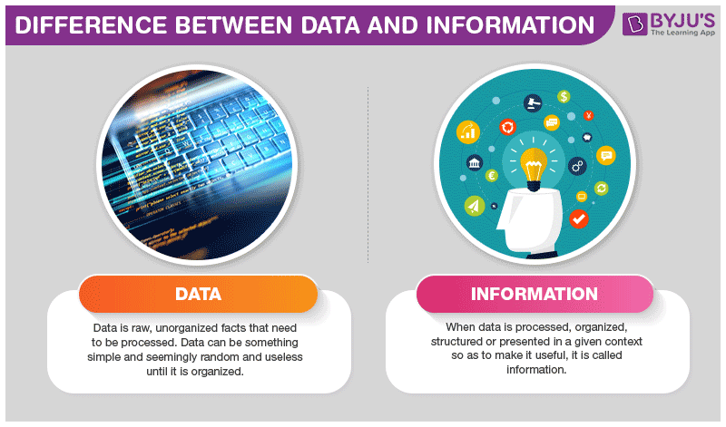
Figure 1: Difference between data & information (BYJUS, 2023)

1.1.2 Usage of Data and Information in Business Processes

The integration of data and information into business processes is essential for optimizing operations and improving decision-making. Here are some keyways they are utilized:

- Performance Tracking: Businesses collect data on various metrics such as sales figures, customer interactions, and operational efficiency. This data is then analyzed to generate reports that help assess performance against goals (Cvijovic, 2024).

- Market Analysis: Organizations leverage data to understand market trends and consumer behaviors. By analyzing customer feedback and sales patterns, businesses can tailor their products and marketing strategies to better meet customer needs (Team, 2018).

- Operational Efficiency: Data-driven insights allow companies to streamline processes by identifying bottlenecks or inefficiencies. For instance, inventory data can reveal patterns that help optimize stock levels and reduce costs (Bourgeois, 2014).

- Strategic Decision-Making: Information derived from data analysis supports strategic decisions by providing a clear picture of the business landscape. This includes identifying new opportunities for growth or areas needing improvement (Team, 2018).

1.1.3 Importance (Value) of Using Data and Information in Business Processes
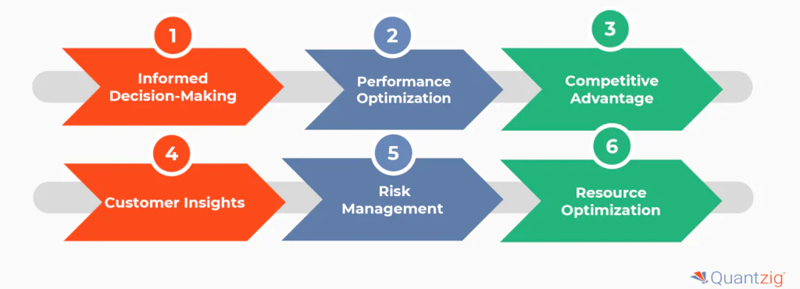
Figure 2: Importance of Using Data and Information in Business Processes (Anirban, 2021)
The value of utilizing data and information in business processes cannot be overstated. Here are several key points highlighting their importance:

- Enhanced Decision-Making: Access to accurate information enables leaders to make informed decisions rather than relying on intuition or guesswork. This leads to better outcomes and minimizes risks associated with poor decision-making (Cvijovic, 2024).
- Competitive Advantage: Organizations that effectively harness data can gain a competitive edge by responding more quickly to market changes and customer demands. This agility allows them to innovate faster than competitors who may not utilize data as effectively (Jain, 2023).
- Customer Insights: By analyzing customer data, businesses can gain valuable insights into preferences and behaviors, leading to improved customer satisfaction and loyalty. Tailored marketing efforts based on this information can significantly boost sales (team, 2024).
- Cost Reduction: Efficient use of data can lead to significant cost savings by identifying inefficiencies in operations or supply chains. For example, predictive analytics can help companies manage inventory more effectively, reducing excess stock costs (Cvijovic, 2024).

the effective use of data and information is vital for modern businesses. Understanding the distinction between raw data and processed information allows organizations to leverage these assets strategically. By integrating data-driven insights into their business processes, companies can enhance decision-making, gain competitive advantages, improve customer satisfaction, and reduce costs.

  - Data Generation and Tools for Data Manipulation

1.2.1 How Data is Generated
Data generation refers to the process of collecting raw information from various sources. This data serves as the foundation for decision-making and insights.
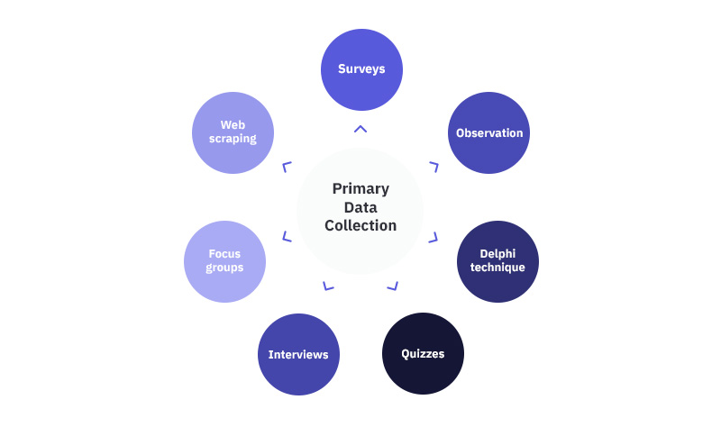
Figure 3: Primary data collection methods (Maione, 2023)

Below are some common methods of primary data generation:
- Interviews:
  - Data is gathered through structured, semi-structured, or unstructured conversations.
  - Useful for qualitative insights, such as understanding user behavior or opinions (Taherdoost, 2021).
- Surveys:
  - Structured questionnaires are distributed to respondents to collect quantitative or qualitative data.
  - Examples include online forms, telephone surveys, or in-person questionnaires (Taherdoost, 2021).
- Point of Sales (POS) Systems:
  - Transactional data is recorded at the time of purchase.
  - Includes details such as product type, price, and time of purchase, helping businesses track sales and inventory (Cote, 2021).

- Sensor Data:
  - Sensors in devices like IoT systems, industrial machinery, or environmental monitors generate real-time data.
  - Examples include temperature readings, motion detection, and GPS tracking (Cote, 2021).
- Social Media Data:
  - Generated from platforms like Twitter, Facebook, and Instagram.
  - Includes user interactions such as likes, shares, comments, and posts (Cote, 2021).

1.2.2 The Tools Used to Manipulate Data to Make Them Meaningful
To transform raw data into meaningful insights, various tools and techniques are employed. These tools facilitate data cleaning, processing, analysis, and visualization.
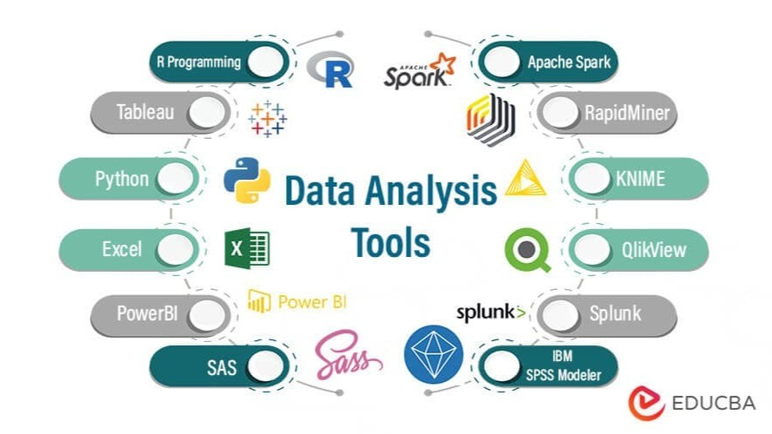
Figure 4: Data analysis & manipulation tools (P, 2024)
Below are some widely used tools:
- Microsoft Excel:
  - A versatile spreadsheet application used for basic data manipulation tasks such as sorting, filtering, and formula-based calculations.
  - Features like PivotTables and data visualization tools (charts and graphs) enhance data interpretation (Coursera, 2023).

- Power BI:
  - A business intelligence tool for data visualization and reporting.
  - Integrates with various data sources to create interactive dashboards and detailed reports (Coursera, 2023).
- Programming Languages (e.g., Python, R):
  - Python:
    - Libraries like Pandas, NumPy, and Matplotlib enable data manipulation, statistical analysis, and visualization.
  - R:
    - Popular in statistical analysis and data science for handling complex datasets (Rane, 2022).
- SQL (Structured Query Language):
  - Used for managing and querying relational databases.
  - Enables data extraction, updating, and organization efficiently (Rane, 2022).
- Tableau:
  - A data visualization tool that transforms complex datasets into interactive and shareable dashboards.
  - Useful for exploring trends and patterns in data (Rane, 2022).
- ETL Tools (Extract, Transform, Load):
  - Tools like Apache NiFi, Talend, or Informatica automate the process of data extraction, transformation, and loading into a target system (Coursera, 2023).

By leveraging these tools, organizations can ensure that data is not only accurate but also actionable, supporting better decision-making and strategic planning.

1.3 Assessing the Value of Data and Information for Real-World Business Organizations
Data and information are vital assets for modern business organizations, driving decision-making, innovation, and competitive advantage. This report assesses the value of data and information by examining real-world examples of companies such as WhatsApp, Amazon, and Facebook.

1.3.1 The Importance of Data and Information
Data serves as the raw material for generating insights, while information represents processed and contextualized data. Together, they enable businesses to:

- Understand Customer Behavior:
  - By analyzing customer interactions, companies can identify preferences and trends.
  - Example: Amazon uses purchase history, browsing behavior, and wish lists to recommend products to users (Pathak, 2020).
- Improve Operational Efficiency:
  - Data helps optimize supply chains, reduce waste, and enhance resource allocation.
  - Example: Amazon’s warehouses use data-driven robotics and algorithms to streamline order fulfillment (Pathak, 2020).
- Enhance Decision-Making:
  - Information derived from data supports strategic decisions.
  - Example: Facebook leverages user engagement metrics to prioritize content in users' feeds (Shibu, 2024).
- Drive Innovation:
  - Data fuels the development of new products and services.
  - Example: WhatsApp uses messaging data patterns to enhance features like encryption and multimedia sharing (Rastogi, 2017).

1.3.2 Case Studies

- WhatsApp:
  - Why Data is Important:
WhatsApp collects minimal user data but uses metadata (e.g., frequency of messages, group participation) to improve its platform’s performance and security (Rastogi, 2017).
  - Value of Information:
Metadata is crucial for identifying spam, improving encryption protocols, and optimizing server loads (Rastogi, 2017).
  - Example Impact:
The app’s data-light model enables seamless communication even in low-bandwidth regions, boosting global user adoption (Page, 2019).

- Amazon:
  - Why Data is Important:
Amazon collects vast amounts of customer data, including purchase history, search queries, and delivery locations (Pathak, 2020).
  - Value of Information:
This information drives personalized recommendations, dynamic pricing, and inventory management (Pathak, 2020).
  - Example Impact:
In 2022, Amazon’s recommendation engine accounted for up to 35% of total sales, showcasing the power of data-driven personalization (Engine, 2022).

- Facebook (Meta):
  - Why Data is Important:
Facebook collects user-generated content, interactions, and demographic information (Shibu, 2024).
  - Value of Information:
This data is used for targeted advertising, which constitutes the majority of Facebook’s revenue (Shibu, 2024).
  - Example Impact:
In 2023, Meta’s ad revenue reached $131 billion, demonstrating how data monetization supports business growth (Dixon, 2024).
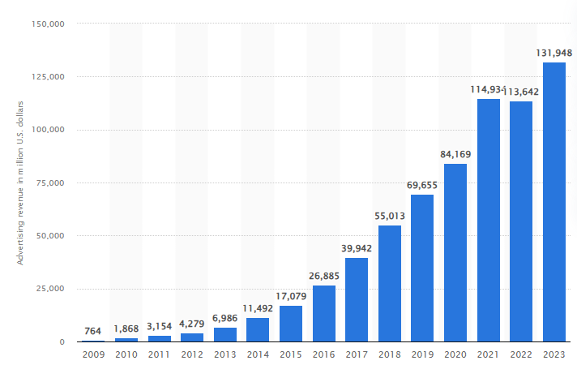
Figure 5: Annual advertising revenue of Meta Platforms worldwide from 2009 to 2023 (Dixon, 2024)

1.4 Evaluating the Wider Implications of the Usage of Data and Information in Sampath Food City (PVT) Ltd

1.4.1 Importance of Data for Sampath Food City (PVT) Ltd
The data and information collected by Sampath Food City (PVT) Ltd play a pivotal role in enhancing operational efficiency, strategic decision-making, and customer satisfaction. Below are the specific areas highlighted in the scenario and their implications:

1. Best-Selling Products Analysis
Importance: Identifying top-selling products helps optimize inventory management, reduce stockouts, and increase overall sales.
Implications:
- Operational Efficiency: Ensures that popular products are always in stock, avoiding lost sales opportunities.
- Customer Satisfaction: Availability of high-demand items improves the shopping experience.
- Financial Growth: Increased sales of best-selling products lead to higher revenues (Campagna, 2024).

2. Product Performance Analysis
Importance: Evaluating individual product performance over time allows the business to make informed decisions regarding pricing, promotion, and placement.
Implications:
- Strategic Marketing: Promotions can be targeted toward underperforming products to increase their sales.
- Cost Optimization: Poorly performing products can be phased out to save storage costs.
- Enhanced Revenue: Focused marketing and pricing strategies drive better financial results (Campagna, 2024).

3. Sales Trends Analysis
Importance: Analyzing sales trends helps in forecasting future demand and aligning inventory and marketing strategies.
Implications:
- Demand Forecasting: Enables accurate prediction of peak seasons or product demand fluctuations.
- Inventory Optimization: Reduces overstocking or understocking issues.
- Marketing Effectiveness: Helps design campaigns that align with anticipated customer needs (Anita Balchandani).

4. Customer Behavior Analysis
Importance: Understanding customer behavior provides insights into purchase patterns, preferences, and spending habits.
Implications:
- Personalized Customer Experience: Offers tailored promotions or loyalty rewards based on customer preferences.
- Customer Retention: Builds stronger relationships with customers by addressing their needs.
- Revenue Growth: Encourages repeat purchases and increases the average transaction value (Tkalych, 2023).

5. Regional Sales Analysis
Importance: Analyzing sales data across different regions helps identify geographical performance disparities.
Implications:
- Targeted Strategies: Allows regional marketing efforts to address specific challenges or opportunities.
- Resource Allocation: Directs resources, such as stock and workforce, to regions with higher demand.
- Network Expansion: Provides insights into potential areas for opening new branches (Safna, 2024).

1.4.2 Wider Implications of Data and Information Usage
1. Business Growth and Competitiveness
Effective data utilization positions Sampath Food City (PVT) Ltd to make proactive, informed decisions, thereby gaining a competitive edge in the retail grocery market.

2. Improved Decision-Making
Automated analysis reduces human bias and errors, enabling data-driven decisions that align with customer demands and market trends.

3. Cost Reduction
Efficient inventory management and resource allocation reduce operational costs, maximizing profitability.
4. Technological Advancement
The adoption of a computer-based data analysis application positions Sampath Food City as a tech-savvy organization, enhancing its reputation and attracting tech-conscious customers.

5. Ethical Considerations
With great power comes great responsibility. Sampath Food City must ensure that customer data is used ethically, maintaining transparency and compliance with data protection regulations (e.g., GDPR).

6. Scalability
The computerized application can handle larger datasets as the business grows, making it a scalable solution that supports future expansion.

7. Workforce Optimization
Automating data analysis frees employees to focus on strategic tasks, improving productivity and morale.

The effective use of data and information in Sampath Food City (PVT) Ltd can significantly transform the business by improving operational efficiency, driving revenue growth, and enhancing customer satisfaction. By adopting a computer-based sales data analysis application, the organization can overcome the limitations of manual analysis and gain actionable insights, enabling it to thrive in a competitive market (Invafresh, 2023).

2.1 Implications of Using Data and Information in Business Processes
The integration of data and information into business processes has revolutionized organizational operations, leading to enhanced decision-making and operational efficiency. However, this integration brings forth various social, legal, and ethical implications that businesses must address to maintain trust, comply with regulations, and uphold moral standards.

2.1.1 Social Implications
The utilization of data in business processes significantly impacts society, influencing individual privacy, societal trust, and the digital divide.
- Privacy Concerns: The extensive collection and analysis of personal data can infringe upon individual privacy rights, leading to societal apprehension regarding surveillance and data misuse (Wanbil W. Lee, 2016).
- Trust Erosion: Mismanagement or unethical use of data can erode public trust in organizations, resulting in reputational damage and decreased customer loyalty (Alex Edquist, 2022).
- Digital Divide: The reliance on data-driven technologies may exacerbate social inequalities, as marginalized communities with limited access to digital resources could be excluded from the benefits of such advancements (Atlan, 2023).

2.1.2 Legal Implications
Businesses must navigate a complex landscape of legal requirements to ensure compliance and avoid potential liabilities associated with data usage.
- Data Protection Regulations: Laws such as the General Data Protection Regulation (GDPR) and the California Consumer Privacy Act (CCPA) impose stringent obligations on organizations to protect personal data, with non-compliance resulting in substantial penalties (Gohil, 2023).
- Intellectual Property Rights: Unauthorized use of proprietary data can lead to legal disputes, necessitating that businesses respect intellectual property laws when handling data (Proof, 2022).
- Cybersecurity Obligations: Organizations are legally required to implement robust cybersecurity measures to protect data from breaches, with failure to do so potentially resulting in legal action and loss of consumer trust (Edquist, 2022).

2.1.3 Ethical Implications
Beyond legal compliance, ethical considerations are paramount in guiding responsible data practices within organizations.
- Bias and Discrimination: Data-driven algorithms can perpetuate existing biases, leading to discriminatory outcomes in areas such as hiring or lending. Ethical data practices involve actively identifying and mitigating such biases (De-Arteaga, 2022).
- Transparency and Consent: Ethically, businesses are obligated to be transparent about their data collection and usage practices, ensuring that individuals provide informed consent (Cote, 2021).
- Beneficence and Non-Maleficence: Organizations should use data in ways that benefit stakeholders and avoid causing harm, aligning data practices with the broader social good (Erin, 2024).

The implications of using data and information in business processes are multifaceted, encompassing social, legal, and ethical dimensions. Organizations must adopt comprehensive data governance frameworks that address these implications, ensuring that data practices not only comply with legal standards but also uphold ethical principles and contribute positively to society.

2.2 Common Threats to Data in an Organization and Mitigation Techniques
In the digital age, organizations face numerous threats to their data, which can lead to financial losses, reputational damage, and operational disruptions. Understanding these threats and implementing effective mitigation strategies is crucial for maintaining data integrity and security.

2.2.1 Common Threats to Data in an Organization
- Malware Attacks: Malicious software, such as viruses, worms, and ransomware, can infiltrate organizational systems, leading to data corruption, theft, or loss. For instance, ransomware attacks encrypt critical data, rendering it inaccessible until a ransom is paid (Chaudhary, 2025).
- Phishing and Social Engineering: Attackers use deceptive communications to trick individuals into revealing sensitive information or granting unauthorized access. Phishing emails often appear legitimate, leading recipients to disclose credentials or click on malicious links (Group, 2024).
- Insider Threats: Employees, contractors, or partners with authorized access may intentionally or unintentionally compromise data security. Insider threats can result from malicious intent or negligence, leading to data breaches (Team, 2018).
- Password Spraying: This attack involves attempting common passwords across multiple accounts, exploiting weak password policies to gain unauthorized access. Notably, a cyber-attack on Microsoft led to data exposure from its executives and cybersecurity team through such methods (Ullrich, 2024).
- Supply Chain Attacks: Cybercriminals target less-secure elements within an organization's supply chain to infiltrate systems, compromising data through trusted third parties (Group, 2024).

2.2.2 Mitigation Techniques for Common Data Threats
- Regular Software Updates and Patch Management: Keeping software and systems up-to-date addresses known vulnerabilities, reducing the risk of exploitation by malware and other threats (Agency, 2018).
- Employee Training and Awareness Programs: Educating staff about phishing, social engineering, and security protocols empowers them to recognize and avoid potential threats, strengthening the organization's human firewall (Atumu, 2025).
- Robust Access Controls: Implementing strict access controls ensures that individuals have the minimum necessary permissions, reducing the potential impact of insider threats. Regular reviews and adjustments of access rights are essential (riskxchange, 2024).
- Strong Password Policies and Multi-Factor Authentication (MFA): Enforcing complex password requirements and implementing MFA add layers of security, making unauthorized access more difficult (JPMorgan, 2022).
- Comprehensive Backup Solutions: Regularly backing up critical data ensures that organizations can recover information in the event of data loss or ransomware attacks, maintaining business continuity (Drive, 2024).
- Continuous Network Monitoring and Incident Response Planning: Proactive monitoring of networks enables the early detection of anomalies, while a well-defined incident response plan ensures swift action to mitigate threats and minimize damage (ontinue, 2023).

Organizations must remain vigilant against a variety of data threats by implementing comprehensive security measures. A proactive approach, combining technological solutions with employee education and robust policies, is essential to safeguard data and maintain trust in today's interconnected world.

2.3 Analysis of the Impact of Using Data and Information in Real-World Business Processes
Data and information are fundamental to modern business operations, enabling companies to optimize processes, improve customer experiences, and drive innovation. However, their use also raises challenges, such as privacy concerns, security risks, and ethical dilemmas.

2.3.1 Impact of Using Data and Information at Amazon
Personalized Shopping Experience (positive impact):
- Amazon leverages customer data to provide personalized recommendations, enhancing user experience and increasing sales.
- The recommendation system uses machine learning to analyze past purchases and browsing behavior.
- Example: Amazon’s AI-driven product suggestions help improve conversion rates and customer satisfaction (Amazon, 2024).
Optimized Supply Chain and Inventory Management (positive impact):
- Real-time data analytics helps Amazon predict demand, manage inventory, and reduce delivery times.
- Amazon’s anticipatory shipping model predicts potential purchases to optimize stock distribution (Krause, 2024).
Data Privacy and Security Concerns (negative impact):
- Collecting vast amounts of customer data raises concerns about user privacy and potential data breaches.
- Amazon has faced scrutiny over data collection practices and how third-party sellers' data is used (Amazon, 2023).
Worker Surveillance and Ethical Concerns (negative impact):
- Amazon uses data tracking to monitor employee productivity, raising ethical concerns about workplace privacy.
- Warehouse workers have reported stress and burnout due to AI-driven performance tracking (Sainato, 2024).

2.3.2 Impact of Using Data and Information at WhatsApp
Enhanced Communication and Customer Engagement (positive impact):
- WhatsApp Business API enables businesses to interact with customers efficiently, automating responses and improving engagement.
- Small businesses use WhatsApp to handle customer inquiries and orders (Brouwers, 2024).
End-to-End Encryption for Privacy Protection (positive impact):
- WhatsApp ensures secure communication by implementing end-to-end encryption, protecting user data from interception.
- This encryption model enhances user trust in the platform (WhatsApp, 2024).
Misinformation and Fake News Spread (negative impact):
- WhatsApp has been used to spread misinformation, leading to real-world consequences such as violence and political unrest.
- Governments have pressured WhatsApp to regulate forwarded messages to control fake news (Pooja Khurana, 2019).
Data Sharing with Meta (Facebook) (negative impact):
- In 2021, WhatsApp faced backlash over its updated privacy policy, which allowed sharing of metadata with Facebook.
- Users raised concerns about data privacy and many migrated to alternative messaging platforms (Singh, 2025).

2.3.3 Impact of Using Data and Information at Facebook
Targeted Advertising and Business Growth (positive impact):
- Facebook’s data-driven advertising model allows businesses to reach relevant audiences, improving marketing effectiveness.
- Businesses of all sizes benefit from precise audience segmentation (Meta, 2021).
Data-Driven AI Enhancements for User Experience (positive impact):
- Facebook uses AI and data analytics to personalize news feeds, suggest relevant content, and improve engagement.
- The company also leverages data to combat harmful content and misinformation (facebook, 2024).
Privacy Violations and Data Exploitation (negative impact):
- Facebook has faced multiple scandals, including the Cambridge Analytica incident, where personal data was misused for political advertising.
- Concerns about surveillance and user tracking persist (Security, 2023).
Mental Health and Social Impact (negative impact):
- Excessive social media use, fueled by data-driven engagement algorithms, has been linked to mental health issues such as anxiety and depression.
- Facebook’s algorithms are designed to maximize engagement, sometimes amplifying divisive content (Danvers, 2022).

Data and information are powerful tools that drive business growth, efficiency, and innovation. Companies like Amazon, WhatsApp, and Facebook utilize data science to optimize operations, enhance user experiences, and improve business strategies. However, ethical concerns, privacy risks, and misinformation challenges must be carefully managed to ensure responsible data usage.

3.1 Analysis of Data Science Tools and Programming Languages in Supporting Real-World Business Processes
In the contemporary business landscape, data science tools and programming languages play pivotal roles in extracting insights and driving informed decisions. This report explores two sophisticated data science software tools Power BI and Tableau and two prominent programming languages Python and R. We examine their functionalities and how they support real-world business processes.

3.1.1 Sophisticated Data Science Software Tools
a. Power BI

Figure 6: Power BI (Gittleson, 2022)
Power BI, developed by Microsoft, is a business analytics tool that enables users to visualize data and share insights across their organizations. It offers interactive dashboards and reports, facilitating real-time decision-making. Power BI integrates seamlessly with various data sources, including Excel spreadsheets, cloud services, and on-premises databases, making it versatile for diverse business needs. Its user-friendly interface allows non-technical users to create reports without extensive coding knowledge (Shaun Edmond, 2023).

b. Tableau

Figure 7: Tableau (varunsngh, 2019)
Tableau is a powerful data visualization tool widely used for converting raw data into an understandable format. It enables the creation of interactive and shareable dashboards, illustrating trends, variations, and density of data. Tableau connects to various data sources, including SQL databases, spreadsheets, and cloud apps, providing flexibility in data analysis. Its drag-and-drop interface allows users to build visualizations quickly, making it accessible to both technical and non-technical users (Biswal, 2023).

Utilization in Real-World Business Processes
Both Power BI and Tableau are instrumental in supporting business processes by enabling data-driven decision-making. Organizations use these tools to monitor performance metrics, identify trends, and uncover insights that inform strategic planning. For instance, businesses can track sales performance, customer behavior, and operational efficiency through interactive dashboards. These tools also facilitate collaboration by allowing teams to share reports and dashboards, ensuring all stakeholders have access to the same information (Cybernetics, 2024).

3.1.2 Programming Languages Supporting Data Science
a. Python

Figure 8: Python (Python, 2019)
Python is a versatile, general-purpose programming language renowned for its readability and extensive libraries. In data science, Python is utilized for data manipulation, analysis, and machine learning. Libraries such as Pandas and NumPy facilitate data handling, while Matplotlib and Seaborn are used for data visualization. Scikit-learn and TensorFlow provide robust tools for machine learning and deep learning applications. Python's flexibility and extensive community support make it a preferred choice for implementing complex data science workflows (IBM, 2024).

b. R

Figure 9: R language (2020)
R is a programming language and software environment specifically designed for statistical analysis and data visualization. It offers a comprehensive suite of tools for data modeling, statistical testing, and graphical representation. R's packages, such as ggplot2 for visualization and dplyr for data manipulation, are widely used in academic and industry settings. Its capability to handle complex statistical computations makes it invaluable for data scientists focusing on statistical analysis (IBM, 2024).

Utilization in Real-World Business Processes
Python and R are integral to various business processes involving data analysis. Python's versatility allows it to be used in web development, automation, and data science, making it suitable for implementing end-to-end data solutions. R's strength in statistical analysis makes it ideal for tasks requiring in-depth data examination and modeling. Many organizations leverage both languages, using Python for data processing and application development, while utilizing R for detailed statistical analysis (Accedi, 2025).

3.2 Assessing the Benefits of Using Data Science to Solve Problems in Real-World Scenarios
Data science has become integral to the strategic operations of leading global companies, enabling them to harness vast amounts of data to drive decision-making, enhance user experiences, and optimize processes. This report examines how Amazon, WhatsApp, and Facebook leverage data science to address challenges and capitalize on opportunities in their respective domains.

3.2.1 Amazon: Enhancing E-commerce through Data Science
Predictive Analytics and Personalized Recommendations: Amazon utilizes data science to transform the e-commerce landscape by implementing predictive analytics and personalized recommendations. By analyzing historical purchase data and user behaviour, Amazon's recommendation system suggests products tailored to individual preferences, thereby enhancing customer satisfaction and increasing sales (growthsetting, 2023).

Generative AI in Shopping Experience: Amazon has integrated generative AI tools to enhance the shopping experience for customers and sellers. These tools provide personalized product recommendations based on customer preferences, search, browsing, and purchase history, thereby improving customer engagement and satisfaction (Weatherbed, 2024).

AI in Prime Video: Amazon Prime Video leverages AI technology and Next Gen Stats to enhance NFL game broadcasts, simplifying complex game strategies for viewers and improving their understanding of the game (REEDY, 2025).

3.2.2 WhatsApp: Automating Workflows and Enhancing User Experience
Business Automation and Customer Interaction: WhatsApp leverages data science to automate business workflows and improve user interactions. By integrating with platforms like AWS, businesses can automate responses and manage customer interactions more efficiently. This integration allows for real-time processing of messages, enhancing customer service and operational efficiency (Whatsapp, 2022).

Data Analysis of Chat Interactions: WhatsApp enables users to perform data analysis on chat interactions, allowing businesses to gain insights into customer behavior and preferences. This analysis helps in tailoring services and improving customer satisfaction (Agrawal, 2023).

Exploratory Data Analysis (EDA): Users can conduct EDA on exported WhatsApp group chats to gain insights into communication patterns, which can be beneficial for understanding group dynamics and improving communication strategies (Idowu, 2024).

3.3.3 Facebook: Revolutionizing Social Networking and Advertising
Textual Analysis and Facial Recognition: Facebook employs data science to revolutionize social networking and targeted advertising. Through advanced techniques like deep learning, Facebook's "DeepFace" technology achieves high-accuracy facial recognition, enhancing features such as photo tagging. Additionally, Facebook utilizes sentiment analysis on textual data to gauge user emotions and preferences, enabling the delivery of personalized content and advertisements (Team, 2019).

In-House AI Training Chips: Meta (formerly Facebook) has developed its first in-house AI training chip, optimized for AI tasks, to enhance power efficiency and reduce reliance on external suppliers. This initiative is part of Meta's strategy to cut down infrastructure costs associated with its substantial investments in AI (Katie Paul, 2025).

Data for Good Initiative: Facebook's "Data for Good" program leverages data science to help organizations respond to crises and support research that advances economic opportunity, demonstrating the social impact of data-driven initiatives (Jun, 2022).

The integration of data science into business strategies allows companies like Amazon, WhatsApp, and Facebook to solve complex problems, optimize operations, and deliver personalized experiences.

3.3 Evaluating how different data science techniques can be used in the Sampath Food City (PVT) Ltd against user and business requirements

3.3.1 User Requirements and Corresponding Data Science Techniques
- Best-selling Products Analysis:
  - Technique: Descriptive Analytics using Frequency Analysis​
  - Tools/Libraries: Pandas, NumPy​
  - Application: Calculate the frequency of product sales to identify top-selling items. This involves grouping sales data by product ID and counting the number of transactions or total units sold per product (Futuhi, 2020). ​
- Product Performance Analysis:
  - Technique: Time Series Analysis​
  - Tools/Libraries: Pandas, Matplotlib, statsmodels​
  - Application: Analyze sales data over time to assess individual product performance, identify trends, and detect seasonality effects. This helps in making informed decisions about promotions, pricing, and product placement (GeeksforGeeks, 2022).
- Sales Trends Analysis:
  - Technique: Trend Analysis and Forecasting​
  - Tools/Libraries: Pandas, Matplotlib, scikit-learn​
  - Application: Identify overall sales trends and patterns over time, and forecast future sales to inform inventory management and marketing strategies (Davila, 2024).
- Customer Behavior Analysis:
  - Technique: Customer Segmentation using Clustering Algorithms​
  - Tools/Libraries: Pandas, scikit-learn​
  - Application: Segment customers based on purchasing behavior to tailor marketing efforts and improve customer retention. Clustering algorithms like K-means can group customers with similar purchasing patterns (Davila, 2024). ​
- Regional Sales Analysis:
  - Technique: Geospatial Analysis​
  - Tools/Libraries: Pandas, Geopandas, Matplotlib​
  - Application: Analyze sales data across different regions or branches to identify geographical patterns and regional performance. This aids in making location-specific business decisions (ProjectPro, 2024). ​

3.3.2 Business Requirements and Corresponding Data Science Techniques
- Inventory Optimization:
  - Technique: Demand Forecasting using Time Series Analysis​
  - Tools/Libraries: Pandas, statsmodels​
  - Application: Predict future product demand to optimize inventory levels, reduce holding costs, and prevent stockouts (Das, 2024). ​
- Price Optimization:
  - Technique: Price Elasticity Modeling​
  - Tools/Libraries: Pandas, scikit-learn​
  - Application: Analyze how changes in product pricing affect sales volumes to determine optimal pricing strategies (ProjectPro, 2024). ​
- Promotion Effectiveness Evaluation:
  - Technique: A/B Testing​
  - Tools/Libraries: Pandas, scipy​
  - Application: Assess the impact of promotional campaigns by comparing key performance indicators between test and control groups (digital-marketing, 2024). ​
- Customer Churn Prediction:
  - Technique: Predictive Modeling using Classification Algorithms​
  - Tools/Libraries: Pandas, scikit-learn​
  - Application: Predict which customers are likely to stop purchasing, allowing for proactive retention strategies (Rayfield, 2025).
- Market Basket Analysis:
  - Technique: Association Rule Mining​
  - Tools/Libraries: mlxtend​
  - Application: Identify product combinations frequently purchased together to inform cross-selling and promotional strategies (Davila, 2024). ​

Implementing these data science techniques using Python's robust libraries will enable Sampath Food City (PVT) Ltd to automate and enhance their sales data analysis processes.

4.1 Use-Case Diagram: Sales Data Analysis System
Actor:
- Management Team (Primary Actor)
  - Uses the system to collect, clean, and analyze sales data for strategic business decisions.
Use Cases:
- Collect Sales Data
  - Retrieves transaction data from the centralized database for analysis.
- Clean Sales Data
  - Preprocesses the raw sales data by removing errors, duplicates, and handling missing values.
- Analyze Best-Selling Products
  - Identifies top-selling products to optimize stock and meet customer demand.
- Perform Product Performance Analysis
  - Evaluates the performance of individual products over time for pricing, placement, and promotions.
- Analyze Sales Trends
  - Detects patterns in sales over a timeline for forecasting and inventory planning.
- Analyze Customer Behaviour
  - Examines customer purchasing habits, including total amount spent and the number of items purchased.
- Conduct Regional Sales Analysis
    - Provides insights into sales performance across different regions or supermarket branches.
Relationships:
- Management Team interacts with all analysis use cases (1-7).
- <<Include>> relationships:
  - Collect Sales Data <<include>> Clean Sales Data
  - Each analysis use case (3-7) <<include>> Clean Sales Data
(All analysis depends on cleaned data to ensure accuracy.)

Visual Representation
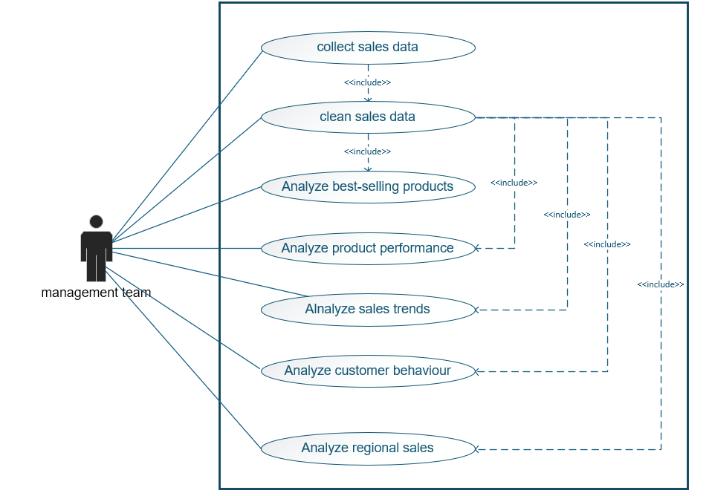
Figure 10: Use-case diagram for Sampath Food city (PVT) Ltd. scenario

4.2 Implementing a data science-based application using Python programming language by using built-in Python data science libraries.

Step 1: Load the Dataset and Initial Setup
Before performing any analysis, we need to import required libraries and load the dataset. In this step, we:
- Import necessary libraries.
- Read the CSV file.

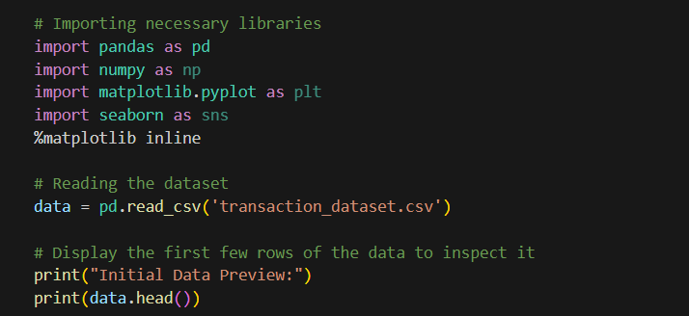
Figure 11: Import Libraries and Load dataset code segment
Explanation:
- Library Imports: We use pandas for data manipulation, numpy for numerical operations, and matplotlib/seaborn for visualizations.
- Data Loading: The CSV is read using pd.read_csv().

Step 2: Data Preprocessing
Before performing any analysis, we need to pre-process and clean the data. In this step we:
- Convert the Date column to a datetime type.
- Calculate a new column (TotalPrice) as the product of Quantity and PriceperUnit.
- (Optionally) Remove duplicates or handle any missing values.
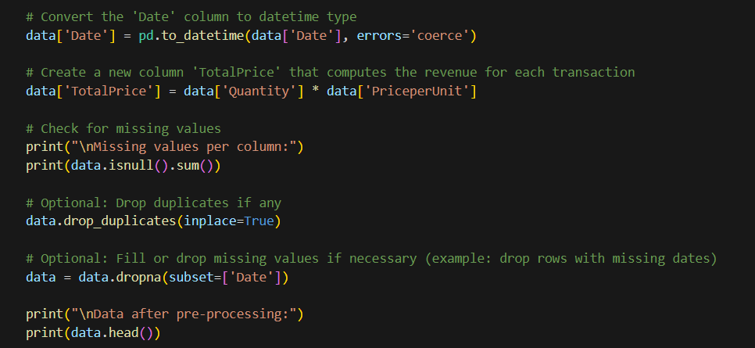
Figure 12: Data Pre-processing code segment
Explanation:
- Date Conversion: Converting the Date column to datetime ensures proper handling of dates for time series analysis.
- Revenue Calculation: A new column, TotalPrice, is created for revenue per transaction.
- Data Cleaning: We check for missing values and remove duplicates to ensure data integrity.

Step 3: Best-selling Products Analysis
We analyze which products are the best-selling by summing the Quantity sold per product.
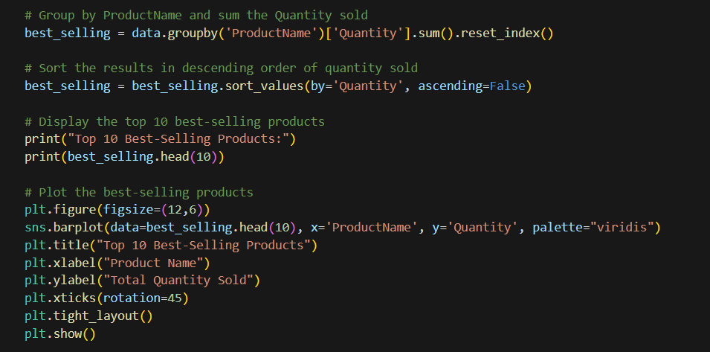
Figure 13: Best-selling products analysis code segment
Explanation:
- Grouping & Aggregation: The data is grouped by ProductName and the quantities are summed up to find total sales per product.
- Sorting: The products are sorted to identify the top performers.
- Visualization: A bar chart shows the top 10 best-selling products, which helps quickly identify the items in high demand.

Step 4: Product Performance Analysis
Here we assess the performance of each product over time. We aggregate total revenue by product and date. We optimized this graph to show the monthly performance of products.
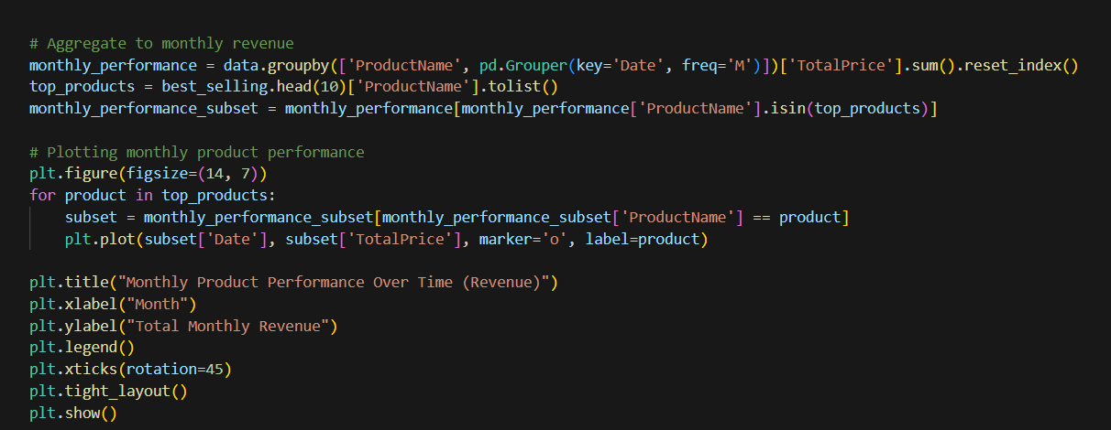
Figure 14: Product performance analysis code segment
Explanation:
- Grouping: We group by both ProductName and Date to see how each product’s revenue changes over time.
- Visualization: A line chart depicts trends in revenue over time for the selected products.

Step 5: Sales Trends Analysis
This analysis examines overall sales trends over time. We aggregate total revenue on a monthly basis.
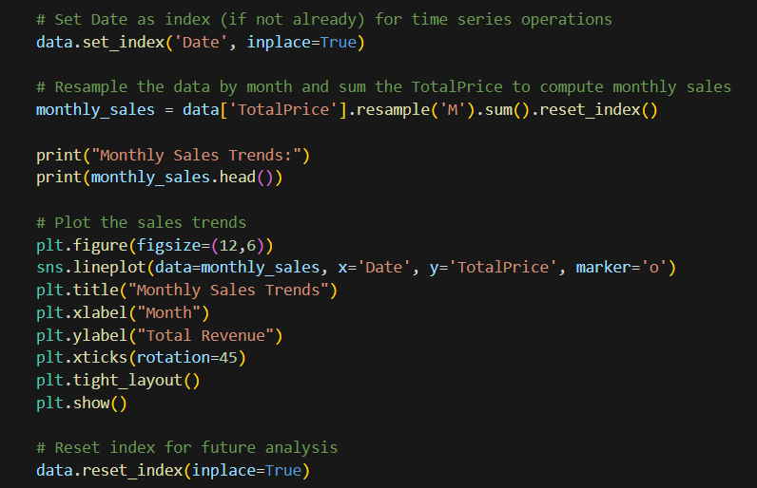
Figure 15: Sales trends analysis code segment
Explanation:
- Resampling: The data is resampled by month using the resample('M') method to calculate monthly revenue.
- Visualization: A line chart helps to visualize the sales trends over months, useful for forecasting and strategic planning.

Step 6: Customer Behaviour Analysis
In this step, we analyze customer behavior by calculating:
- Total number of items purchased.
- Total amount spent per customer.
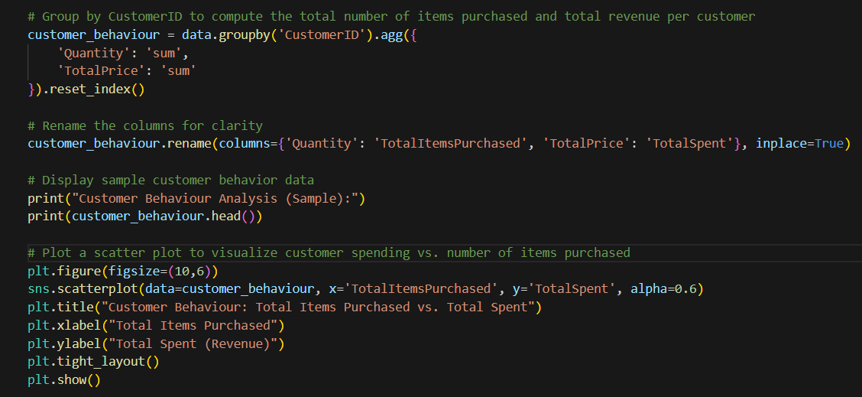
Figure 16: Customer behaviour analysis code segment
Explanation:
- Aggregation: We group by CustomerID and aggregate the sum of Quantity and TotalPrice to understand purchasing patterns.
- Visualization: A scatter plot is used to identify trends and outliers in customer spending and purchasing habits.

Step 7: Regional Sales Analysis
Here, we analyze the sales performance across different regions by summing the total revenue for each region.
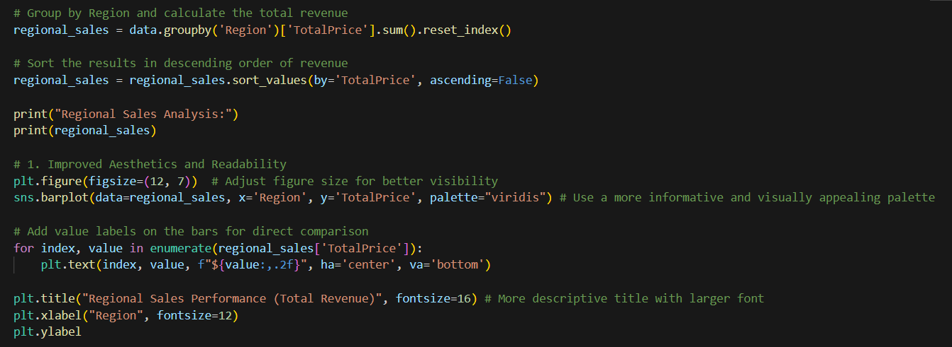
Figure 17: regional sales analysis code segment
Explanation:
- Grouping & Aggregation: We group the data by Region and sum the TotalPrice to get revenue by region.
- Sorting & Visualization: The bar chart helps compare regional performance, identifying which regions contribute most to overall sales.

4.3 Leveraging Data Science for Enhanced Performance at Sampath Food City: An Analytical Business Performance Analysis Report & Recommendations.

1. Best-Selling Products
Evidence:
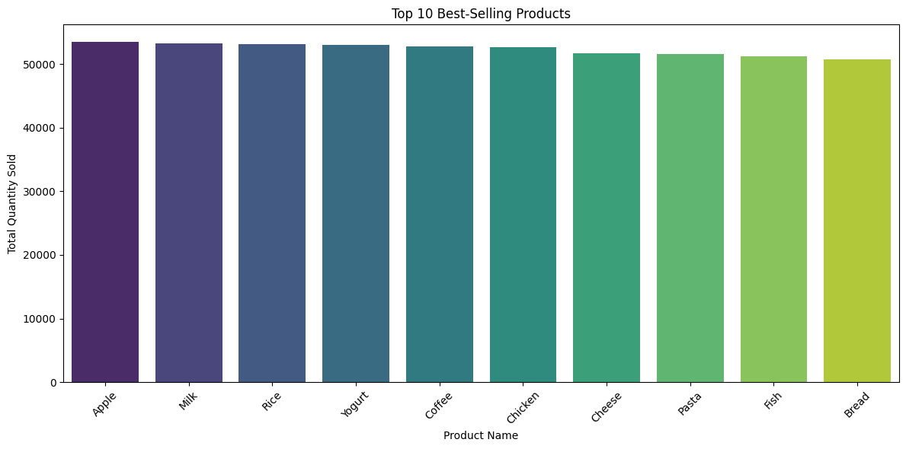
Figure 18: Best-selling products analysis plot
Analysis: The bar chart illustrates the top 10 best-selling products based on total quantity sold. The products that top the sales include:
Apple, Milk, Rice, Yogurt, Coffee, Chicken, Cheese, Pasta, Fish and Bread.

The sales volume across these products is relatively consistent, indicating a high and stable demand for essential grocery and food items. Apple ranks as the highest in total units sold, reflecting its popularity and possibly competitive pricing or frequent promotional offers.

Recommendation: The organization should prioritize inventory management and ensure adequate stock levels for these top-selling products. Additionally, bundling or promotional campaigns involving these products may further increase customer engagement and sales volume (capital, 2020).

2. Product Performance Over Time
Evidence:
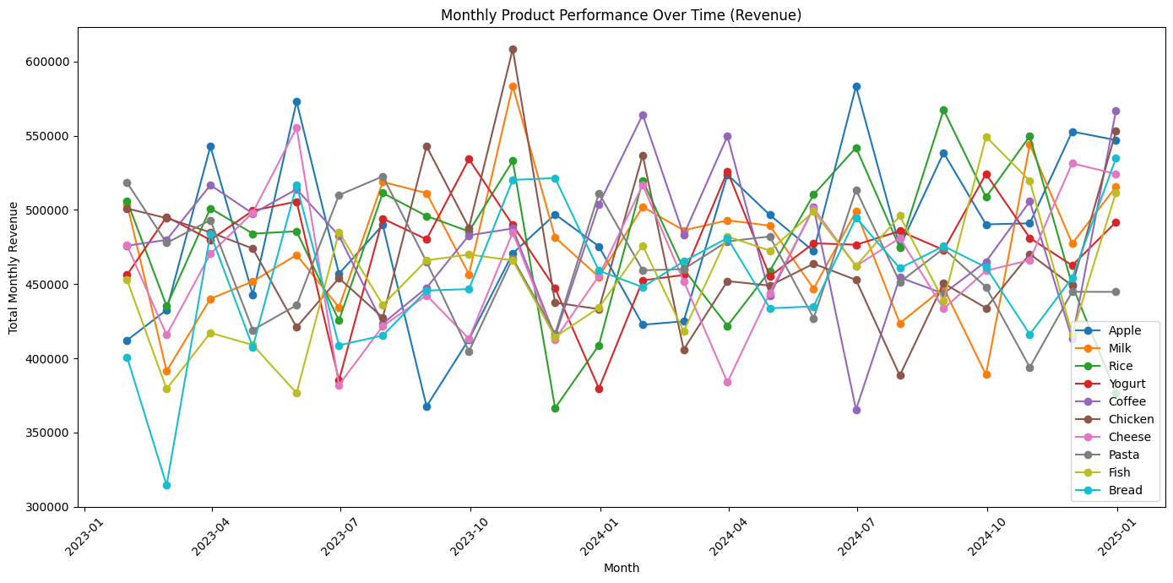
Figure 19: Product performance analysis plot
Analysis: This multi-line graph presents the monthly revenue performance of each product over a span of two years. All products demonstrate fluctuating revenue trends, with periodic peaks and troughs, indicating seasonality or external market influences.

Key observations:
- Apple, Milk, and Rice frequently appear among the higher revenue-generating products.
- Some months show significant spikes, which could correspond to promotional periods or seasonal demands.

Recommendation: The company should perform further temporal analysis to determine seasonality effects and align marketing strategies accordingly. For example, running targeted campaigns before peak months can amplify sales. Forecasting models can also be implemented to improve revenue predictability and stock control (Woods, 2024).

3. Sales Trends
Evidence:
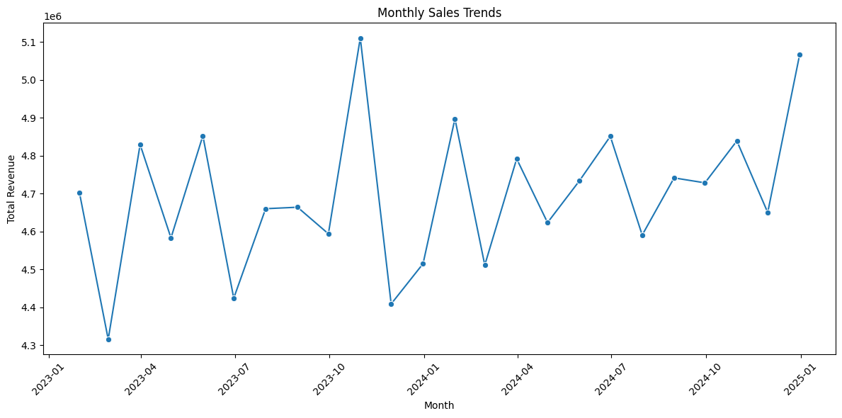
Figure 20: Sales trends analysis plot
Analysis: This line graph displays overall monthly revenue trends across all products. The graph demonstrates a general upward trend, suggesting growth in overall sales performance over the two-year period. Despite minor fluctuations, the trend shows positive momentum, especially towards the end of the observed timeline.

Recommendation: The organization should capitalize on the observed growth trend by:
- Investing in strategic advertising during months with historical dips.
- Expanding distribution channels during peak periods.
- Analyzing the reasons behind peak revenue months to replicate successful practices (Mailchimp, 2024).

4. Customer Behaviour Analysis
Evidence:
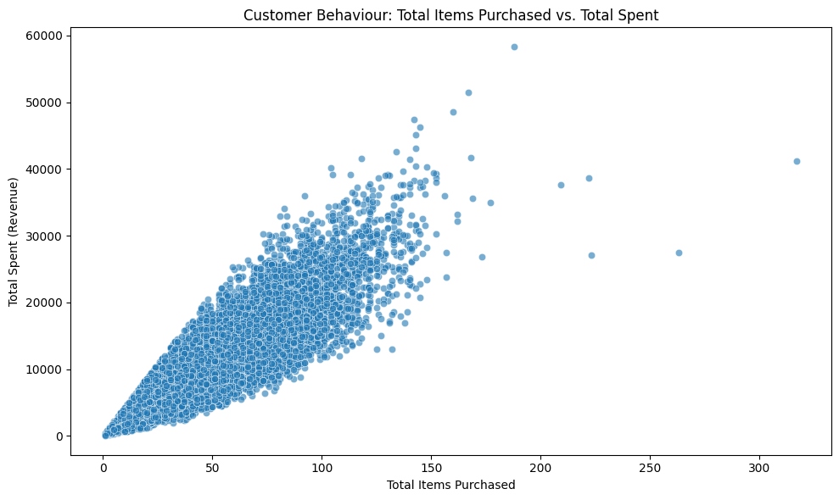
Figure 21: customer behaviour analysis plot
Analysis:
The scatter plot shows a strong positive relationship between the total number of items purchased and the total revenue spent by customers. Most data points are concentrated around lower-to-mid range purchases and spending, indicating the majority of customers tend to make small to moderate purchases. However, a few notable outliers show customers spending significantly more despite not purchasing a large quantity of items—suggesting potential high-value or premium product purchases.

Recommendations:
- Introduce a tiered loyalty program to encourage repeat purchases from high-value customers.
- Use customer segmentation to target mid-range spenders with promotions or bundles to increase their spending.
- Analyze the spending behavior of outliers to identify high-margin products or services and promote them more widely (Wadarajan, 2022).

5. Regional Sales Analysis
Evidence:
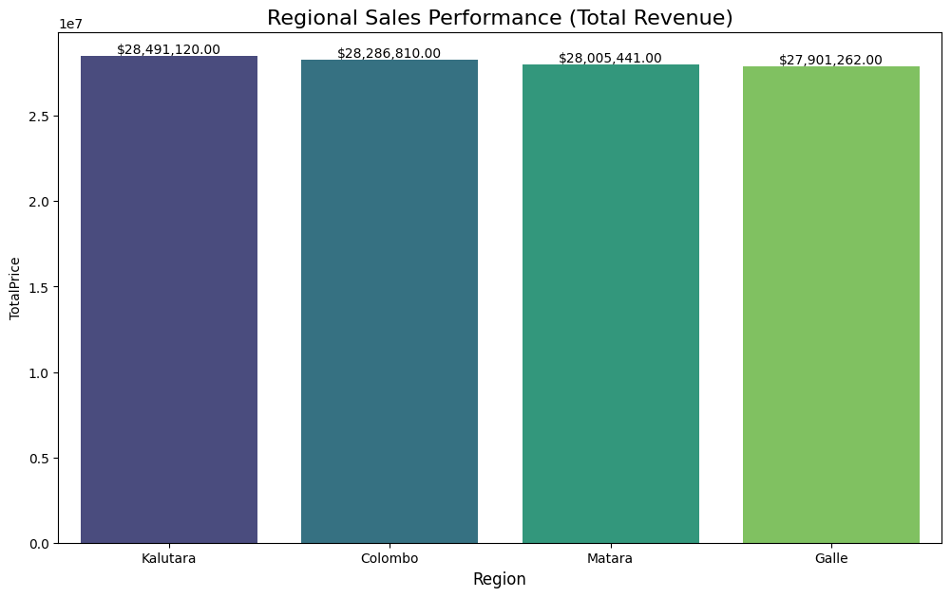
Figure 22: Regional sales analysis plot
Analysis:
The bar chart indicates fairly even sales performance across all four regions: Kalutara, Colombo, Matara, and Galle. Kalutara has the highest total revenue, slightly outperforming the others. The minimal difference in regional revenue suggests strong operational balance and consistent demand across regions.

Recommendations:
- Invest more in Kalutara to build on its top performance, possibly with regional promotions or expanded product offerings.
- Use Kalutara’s strategies as a benchmark for boosting sales in other regions.
- Consider localized marketing campaigns tailored to each region to capitalize on regional preferences and maintain balanced growth (Younger, 2024).

Conclusion
The implementation of a data-driven sales analysis system has proven to be a transformative step for Sampath Food City (PVT) Ltd. By leveraging data science techniques, the organization can make informed business decisions, reduce operational inefficiencies, and enhance customer satisfaction. The study highlights the importance of automating data analysis to overcome the limitations of manual processes. Moreover, it underscores the significance of ethical data usage and security measures in protecting business information. Overall, the integration of Python-based data science solutions presents a viable approach to optimizing business processes, demonstrating the value of data analytics in the modern retail industry.

References
Accedi, 2025. Domo.com. [Online]
Available at: https://www.domo.com/it/glossary/how-to-use-r-and-python
[Accessed 17 3 2025].
Agency, N. S., 2018. NSA'S Top Ten Cybersecurity Mitigation Strategies, s.l.: s.n.
Agrawal, R., 2023. Analytics Vidhya. [Online]
Available at: https://www.analyticsvidhya.com/blog/2023/02/whatsapp-chat-analysis-end-to-end-data-analysis-project-with-deployment/
[Accessed 17 3 2025].
Alex Edquist, L. G. S. G. K. R., 2022. McKinsey & Company. [Online]
Available at: https://www.mckinsey.com/capabilities/mckinsey-digital/our-insights/data-ethics-what-it-means-and-what-it-takes
[Accessed 2 3 2025].
Amazon, 2023. Amazon.com. [Online]
Available at: https://www.amazon.com/gp/help/customer/display.html?nodeId=GX7NJQ4ZB8MHFRNJ
[Accessed 22 03 2025].
Amazon, 2024. Amazon Web Services, Inc.. [Online]
Available at: https://aws.amazon.com/personalize/
[Accessed 23 3 2025].
Anirban, 2021. Quantzig. [Online]
Available at: https://www.quantzig.com/blog/importance-business-analytics/
[Accessed 28 1 2025].
Anita Balchandani, S. P., n.d. www.mckinsey.com. [Online]
Available at: https://www.mckinsey.com/uk/our-insights/the-mckinsey-uk-blog/how-data-is-becoming-pivotal-for-grocery-retailers
[Accessed 30 1 2025].
Anon., 2020. UXWing. [Online]
Available at: https://uxwing.com/r-programming-language-icon/
[Accessed 17 3 2025].
Atlan, T., 2023. Atlan.com. [Online]
Available at: https://atlan.com/data-ethics-examples/
[Accessed 2 3 2025].
Atumu, M., 2025. Liquid Web. [Online]
Available at: https://www.liquidweb.com/blog/mitigate-security-risk
[Accessed 3 3 2025].
Biswal, A., 2023. Simplilearn.com. [Online]
Available at: https://www.simplilearn.com/tutorials/power-bi-tutorial/power-bi-vs-tableau
[Accessed 17 3 2025].
Bourgeois, D. T., 2014. pressbooks. [Online]
Available at: https://pressbooks.pub/bus206/back-matter/answers-to-study-questions/
[Accessed 6 1 2025].
Brouwers, C., 2024. CM.com. [Online]
Available at: https://www.cm.com/en-sg/blog/quality-customer-engagement-whatsapp-business-platform/
[Accessed 22 03 2025].
BYJUS, 2023. BYJUS. [Online]
Available at: https://byjus.com/biology/difference-between-data-and-information/
[Accessed 27 1 2025].
Campagna, D., 2024. Glew.io. [Online]
Available at: https://www.glew.io/articles/how-retail-analytics-can-boost-sales-and-customer-insights-glew
[Accessed 30 1 2025].
capital, f., 2020. faster capital. [Online]
Available at: https://fastercapital.com/articles/How-to-analyze-sales-trends-using-predictive-techniques.html
[Accessed 05 04 2025].
CHAN, K., 2024. AP News. [Online]
Available at: https://apnews.com/article/privacy-encryption-signal-whatsapp-9faf31ed3411bc5b7cab0647b4ab224d
[Accessed 3 3 2025].
Chaudhary, A., 2025. New Haven Register. [Online]
Available at: https://www.nhregister.com/opinion/article/ransomware-todays-business-arvin-chaudhary-20035891.php
[Accessed 2 3 2025].
Cote, C., 2021. Business Insights Blog. [Online]
Available at: https://online.hbs.edu/blog/post/data-collection-methods
[Accessed 28 1 2025].
Cote, C., 2021. Harvard Business School Online. [Online]
Available at: https://online.hbs.edu/blog/post/data-ethics
[Accessed 2 3 2025].
Coursera, 2023. Coursera. [Online]
Available at: https://www.coursera.org/articles/data-analysis-tools
[Accessed 28 1 2025].
Cvijovic, D., 2024. databox. [Online]
Available at: https://databox.com/business-analysis-report
[Accessed 6 1 2025].
Cybernetics, A., 2024. Linkedin.com. [Online]
Available at: https://www.linkedin.com/pulse/why-power-bi-tableau-essential-modern-data-analytics-pbmkf
[Accessed 17 3 2025].
Danvers, A., 2022. Psychology Today. [Online]
Available at: https://www.psychologytoday.com/sg/blog/how-do-you-know/202210/facebook-caused-poor-mental-health-the-beginning
[Accessed 22 03 2025].
Das, R., 2024. ask python. [Online]
Available at: https://www.askpython.com/python/examples/optimize-inventory-management
[Accessed 24 3 2025].
Davila, R., 2024. Medium. [Online]
Available at: https://medium.com/%40raymonddavila/online-retail-exploratory-data-analysis-with-python-cf2316890776
[Accessed 23 3 2025].
De-Arteaga, M. F. S. a. S.-T. M., 2022. Algorithmic Fairness in Business Analytics: Directions for Research and Practice. arXiv (Cornell University).
digital-marketing, 2024. Inexture. [Online]
Available at: https://www.inexture.com/python-for-advance-retail-analytics/
[Accessed 23 3 2025].
Dixon, S. J., 2024. Statista. [Online]
Available at: https://www.statista.com/statistics/271258/facebooks-advertising-revenue-worldwide/#statisticContainer
[Accessed 29 1 2025].
Donegan, K., 2020. techtarget. [Online]
Available at: https://www.techtarget.com/searchsecurity/answer/What-are-the-risks-of-social-networking-sites
[Accessed 3 3 2025].
Drive, F., 2024. Fielddrive.com. [Online]
Available at: https://www.fielddrive.com/blog/navigating-emerging-data-security-threats-mitigation-strategies-for-event-organizers
[Accessed 3 3 2025].
Edquist, A. G. L. G. S. a. R. K., 2022. www.mckinsey.com. [Online]
Available at: https://www.mckinsey.com/capabilities/mckinsey-digital/our-insights/data-ethics-what-it-means-and-what-it-takes
[Accessed 2 3 2025].
Engine, R., 2022. www.rebuyengine.com. [Online]
Available at: https://www.rebuyengine.com/blog/the-amazon-effect
[Accessed 29 1 2025].
Erin, 2024. Analytics Platform - Matomo. [Online]
Available at: https://matomo.org/blog/2024/05/data-ethics/
[Accessed 2 3 2025].
facebook, 2024. www.facebook.com. [Online]
Available at: https://www.facebook.com/business/news/Introducing-Enhanced-Gen-AI-Features-and-Other-Tools-to-Help-Build-Your-Business
[Accessed 22 03 2025].
Futuhi, A., 2020. Medium. [Online]
Available at: https://medium.com/swlh/product-sales-analysis-using-python-863b29026957
[Accessed 24 3 2025].
GeeksforGeeks, 2022. GeeksforGeeks. [Online]
Available at: https://www.geeksforgeeks.org/active-product-sales-analysis-using-matplotlib-in-python
[Accessed 22 3 2025].
Gittleson, W., 2022. www.datacamp.com. [Online]
Available at: https://www.datacamp.com/blog/all-about-power-bi
[Accessed 17 3 2025].
Gohil, R., 2023. www.isba.org.uk. [Online]
Available at: https://www.isba.org.uk/article/importance-data-ethics-why-businesses-must-take-it-seriously
[Accessed 2 3 2025].
GroupSense, I., 2024. Groupsense.io. [Online]
Available at: https://www.groupsense.io/whatsapp-security-concerns-white-paper
[Accessed 3 3 2025].
Group, T. B., 2024. The Baldwin Group. [Online]
Available at: https://baldwin.com/insights/10-cyber-security-threats-to-be-aware-of-this-year/
[Accessed 2 3 2025].
Group, T. B., 2024. The Baldwin Group. [Online]
Available at: https://baldwin.com/insights/10-cyber-security-threats-to-be-aware-of-this-year/
[Accessed 2 3 2025].
growthsetting, 2023. growthsetting. [Online]
Available at: https://growthsetting.com/ai-predictive-analytics/amazon-ai-personalization/
[Accessed 17 3 2025].
IBM, 2024. Ibm.com. [Online]
Available at: https://www.ibm.com/think/topics/python-vs-r
[Accessed 17 3 2025].
Idowu, A., 2024. Medium. [Online]
Available at: https://medium.com/%40idowuadamo2904/exploratory-data-analysis-of-whatsapp-chats-using-python-eb8299021155
[Accessed 17 3 2025].
Invafresh, 2023. www.supermarketperimeter.com. [Online]
Available at: https://www.supermarketperimeter.com/articles/9910-data-driven-success-unleashing-growth-potential-in-the-grocery-retail-industry
[Accessed 31 1 2025].
Jain, S., 2023. Bloomfire. [Online]
Available at: https://bloomfire.com/blog/data-vs-information/
[Accessed 6 1 2025].
JPMorgan, 2022. www.jpmorgan.com. [Online]
Available at: https://www.jpmorgan.com/insights/cybersecurity/ransomware/12-tips-for-mitigating-cyber-risk
[Accessed 3 3 2025].
Jun, H., 2022. Medium. [Online]
Available at: https://medium.com/@hailey_dataforsocialgood/where-data-is-utilized-for-social-good-2-meta-facebook-6a4a28c35692
[Accessed 17 3 2025].
Katie Paul, K. H., 2025. Reuters. [Online]
Available at: https://www.reuters.com/technology/artificial-intelligence/meta-begins-testing-its-first-in-house-ai-training-chip-2025-03-11/
[Accessed 17 3 2025].
Krause, C., 2024. The CDO TIMES. [Online]
Available at: https://cdotimes.com/2024/08/23/case-study-amazons-ai-driven-supply-chain-a-blueprint-for-the-future-of-global-logistics/
[Accessed 22 03 2025].
Mailchimp, 2024. Mailchimp. [Online]
Available at: https://mailchimp.com/resources/seasonal-marketing/
[Accessed 06 04 2025].
Maione, I., 2023. resonio. [Online]
Available at: https://www.resonio.com/blog/primary-data-collection-types-advantages-and-disadvantages/
[Accessed 27 1 2025].
Meta, 2021. Facebook Business. [Online]
Available at: https://www.facebook.com/business/ads
[Accessed 23 03 2025].
Milmo, D., 2025. the Guardian. [Online]
Available at: https://www.theguardian.com/technology/2025/jan/17/russian-hackers-star-blizzard-whatsapp-accounts-ministers-officials
[Accessed 3 3 2025].
ontinue, 2023. Ontinue. [Online]
Available at: https://www.ontinue.com/threat-mitigation/
[Accessed 3 3 2025].
Page, V., 2019. Investopedia. [Online]
Available at: https://www.investopedia.com/articles/personal-finance/040915/how-whatsapp-makes-money.asp
[Accessed 29 1 2025].
Pathak, R., 2020. Analytics Steps. [Online]
Available at: https://www.analyticssteps.com/blogs/how-amazon-uses-big-data
[Accessed 29 1 2025].
P, L. K., 2024. Linkedin.com. [Online]
Available at: https://www.linkedin.com/pulse/data-analysis-tools-logesh-kumar-p-fvp8c/
[Accessed 28 1 2025].
Pooja Khurana, D. K. S. K. ., 2019. Research of Fake News Spreading Through Whatsapp. International Journal of Innovative Technology and Exploring Engineering, 8(6S4), pp. 948-951.
Prasad, S., 2022. paymentservices.amazon.com. [Online]
Available at: https://paymentservices.amazon.com/blog/6-golden-rules-e-commerce-data-protection-cyber-security-strategies-for-2022
[Accessed 3 3 2025].
ProjectPro, 2024. ProjectPro. [Online]
Available at: https://www.projectpro.io/article/top-5-libraries-for-data-science-in-python/196
[Accessed 24 3 2025].
Proof, 2022. www.proof.com. [Online]
Available at: https://www.proof.com/blog/what-legal-teams-and-businesses-should-know-about-ethical-data-mining-and-use-lc
[Accessed 2 3 2025].
Python, 2019. Python.org. [Online]
Available at: Python.org
[Accessed 17 3 2025].
Rane, Z., 2022. Stratascratch.com. [Online]
Available at: https://www.stratascratch.com/blog/the-10-most-useful-data-analysis-tools-for-data-scientists
[Accessed 28 01 2025].
Rastogi, N., 2017. ResearchGate. [Online]
Available at: https://www.researchgate.net/publication/312778290_WhatsApp_security_and_role_of_metadata_in_preserving_privacy
[Accessed 29 1 2025].
Rayfield, B., 2025. Anaconda. [Online]
Available at: https://www.anaconda.com/blog/python-in-excel-for-retail-and-ecommerce
[Accessed 24 3 2025].
REEDY, J., 2025. AP News. [Online]
Available at: https://apnews.com/article/amazon-prime-video-ai-nfl-3297143aabff6f979b9031605c728a33
[Accessed 17 3 2025].
riskxchange, 2024. riskxchange.co. [Online]
Available at: https://riskxchange.co/1007701/top-risk-mitigation-strategies
[Accessed 3 3 2025].
Safna, 2024. retailcloud. [Online]
Available at: https://retailcloud.com/benefits-data-analytics-in-retail-industry
[Accessed 31 1 2025].
Sainato, M., 2024. The Guardian. [Online]
Available at: https://www.theguardian.com/us-news/article/2024/may/21/amazon-surveillance-lawsuit-union
[Accessed 22 03 2025].
Security, T., 2023. www.terranovasecurity.com. [Online]
Available at: https://www.terranovasecurity.com/blog/data-privacy-scandal-facebook
[Accessed 22 03 2025].
Shaun Edmond, M. C., 2023. www.datacamp.com. [Online]
Available at: https://www.datacamp.com/blog/power-bi-vs-tableau-which-one-should-you-choose
[Accessed 17 3 2025].
Shibu, S., 2024. Entrepreneur. [Online]
Available at: https://www.entrepreneur.com/business-news/facebook-youtube-whatsapp-surveil-monetize-user-data-ftc/480188
[Accessed 29 1 2025].
Singh, M., 2025. TechCrunch. [Online]
Available at: https://techcrunch.com/2025/01/22/whatsapp-wins-reprieve-in-india-over-user-data-sharing/?guccounter=1
[Accessed 22 03 2025].
Taherdoost, H., 2021. Data Collection Methods and Tools for Research; A Step-by-Step Guide to Choose Data Collection Technique for Academic and Business Research Projects. International Journal of Academic Research in Management (IJARM), 10(1), pp. 10-38.
Team, D., 2019. DataFlair. [Online]
Available at: https://data-flair.training/blogs/data-science-at-facebook
[Accessed 17 3 2025].
team, I. e., 2024. indeed. [Online]
Available at: https://www.indeed.com/career-advice/career-development/data-in-business
[Accessed 6 1 2025].
Team, P. I., 2018. perceptive. [Online]
Available at: https://www.perceptive.co.nz/blog/what-is-the-difference-between-data-and-information-in-business
[Accessed 6 1 2025].
Team, S. I., 2018. Society Insurance. [Online]
Available at: https://societyinsurance.com/blog/common-data-threats-and-vulnerabilities/
[Accessed 2 3 2025].
Tkalych, D., 2023. dataforest.ai. [Online]
Available at: https://dataforest.ai/blog/how-big-data-analytics-is-transforming-the-retail-industry
[Accessed 30 1 2025].
Ullrich, J., 2024. www.sans.org. [Online]
Available at: https://www.sans.org/blog/three-common-threats-to-your-organization-s-data-to-be-aware-of-on-data-protection-day/
[Accessed 2 3 2025].
varunsngh, 2019. Vocal Media. [Online]
Available at: https://vocal.media/01/what-is-tableau-and-tableau-product-suite
[Accessed 17 3 2025].
Wadarajan, V., 2022. Forbes. [Online]
Available at: https://www.forbes.com/councils/forbestechcouncil/2022/11/18/loyalty-programs-what-works-and-what-doesnt/
[Accessed 6 04 2025].
Wanbil W. Lee, D. F. F. F. F. W. Z. P. a. H. C. C. C. C. D. F., 2016. ISACA. [Online]
Available at: https://www.isaca.org/resources/isaca-journal/issues/2016/volume-6/an-ethical-approach-to-data-privacy-protection
[Accessed 2 3 2025].
Weatherbed, J., 2024. The Verge. [Online]
Available at: https://www.theverge.com/2024/9/19/24249046/amazon-generative-ai-tools-personalized-shopping-recommendations
[Accessed 17 3 2025].
Whatsapp, 2022. WhatsApp.com. [Online]
Available at: https://www.whatsapp.com/join?dept=data-analytics
[Accessed 17 3 2025].
WhatsApp, 2024. faq.whatsapp.com. [Online]
Available at: https://faq.whatsapp.com/820124435853543
[Accessed 22 3 2025].
Woods, M., 2024. camcode. [Online]
Available at: https://www.camcode.com/blog/best-practices-inventory-management/
[Accessed 06 04 2025].
Younger, G., 2024. Highspot. [Online]
Available at: https://www.highspot.com/blog/improve-sales-performance/
[Accessed 7 4 2025].

